* **Sensor based automated irrigation techniques in important agricultural crops**

Conventional surface irrigation is water expensive and costlier. Precision production system through time / volume based automation require human intervention and interpretation, emphasizes for sensor based automation for efficiency and effectiveness. This system provides complete precision irrigation solution considering crop, soil and weather information using AI and IoT. It consisted of Gateway, Soil moisture sensor, Field controller, Solenoid valve, IoT pump controller.

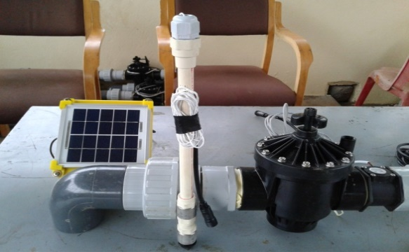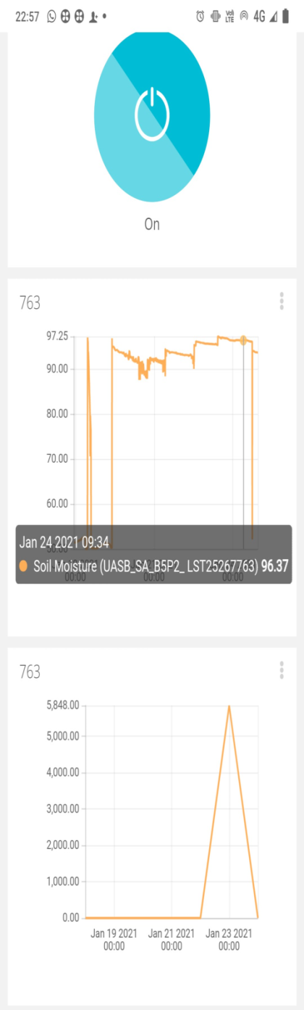 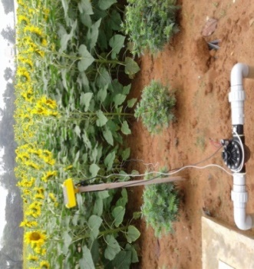 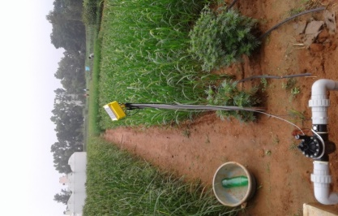 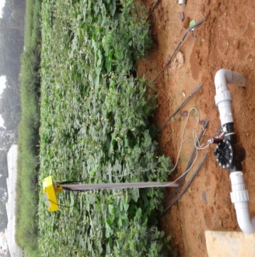

**Soil Moisture sensor Field controller**

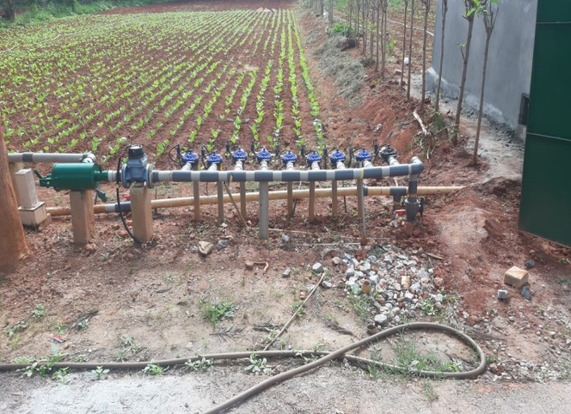 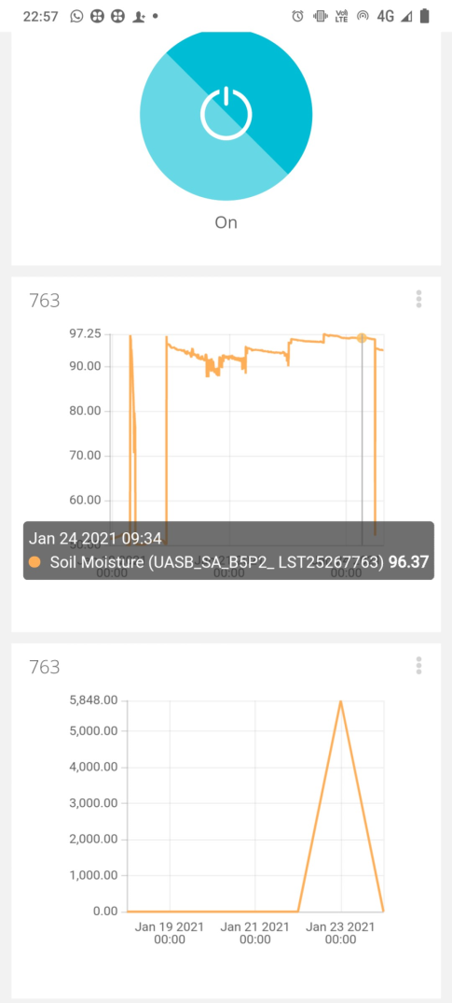 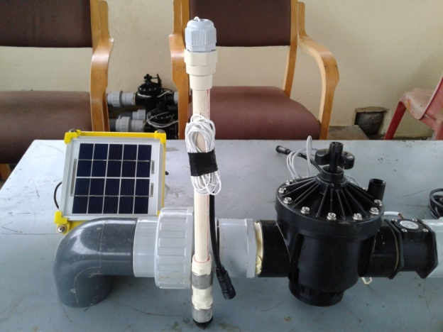

**IoT pump controller Solenoid valve**

* **Laser Spray / Rain Hose Method Of Irrigation** could enhance uniform germination of agricultural and vegetable crop seeds.

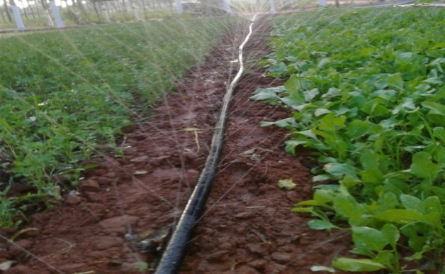

* **Drip irrigation in aerobic rice** saved water to the tune of 45-55 percent apart from reducing methane emission (18-20 Kgs/ha) almost 5 times less over surface flooded irrigation.
* **Drip Irrigation with application of N & K fertilizers** through fertigation in different splits at fortnightly intervals upto flowering enhanced N and K use efficiency upto 65 and 80 percent respectively