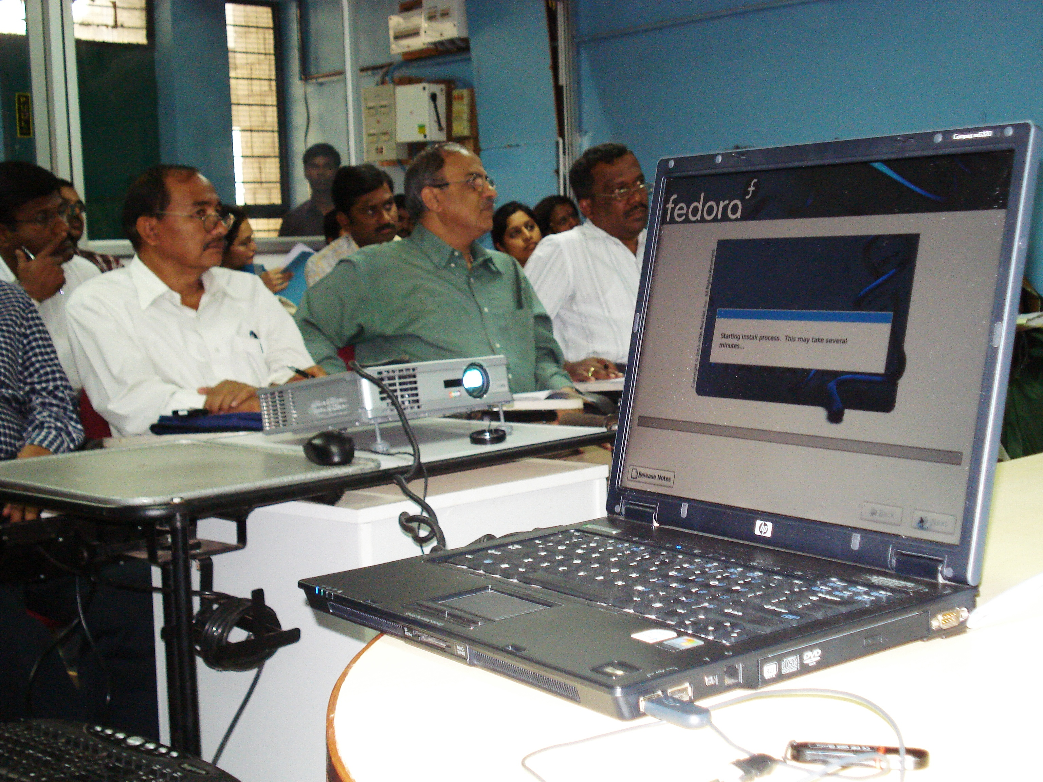

Trainees at classroom.

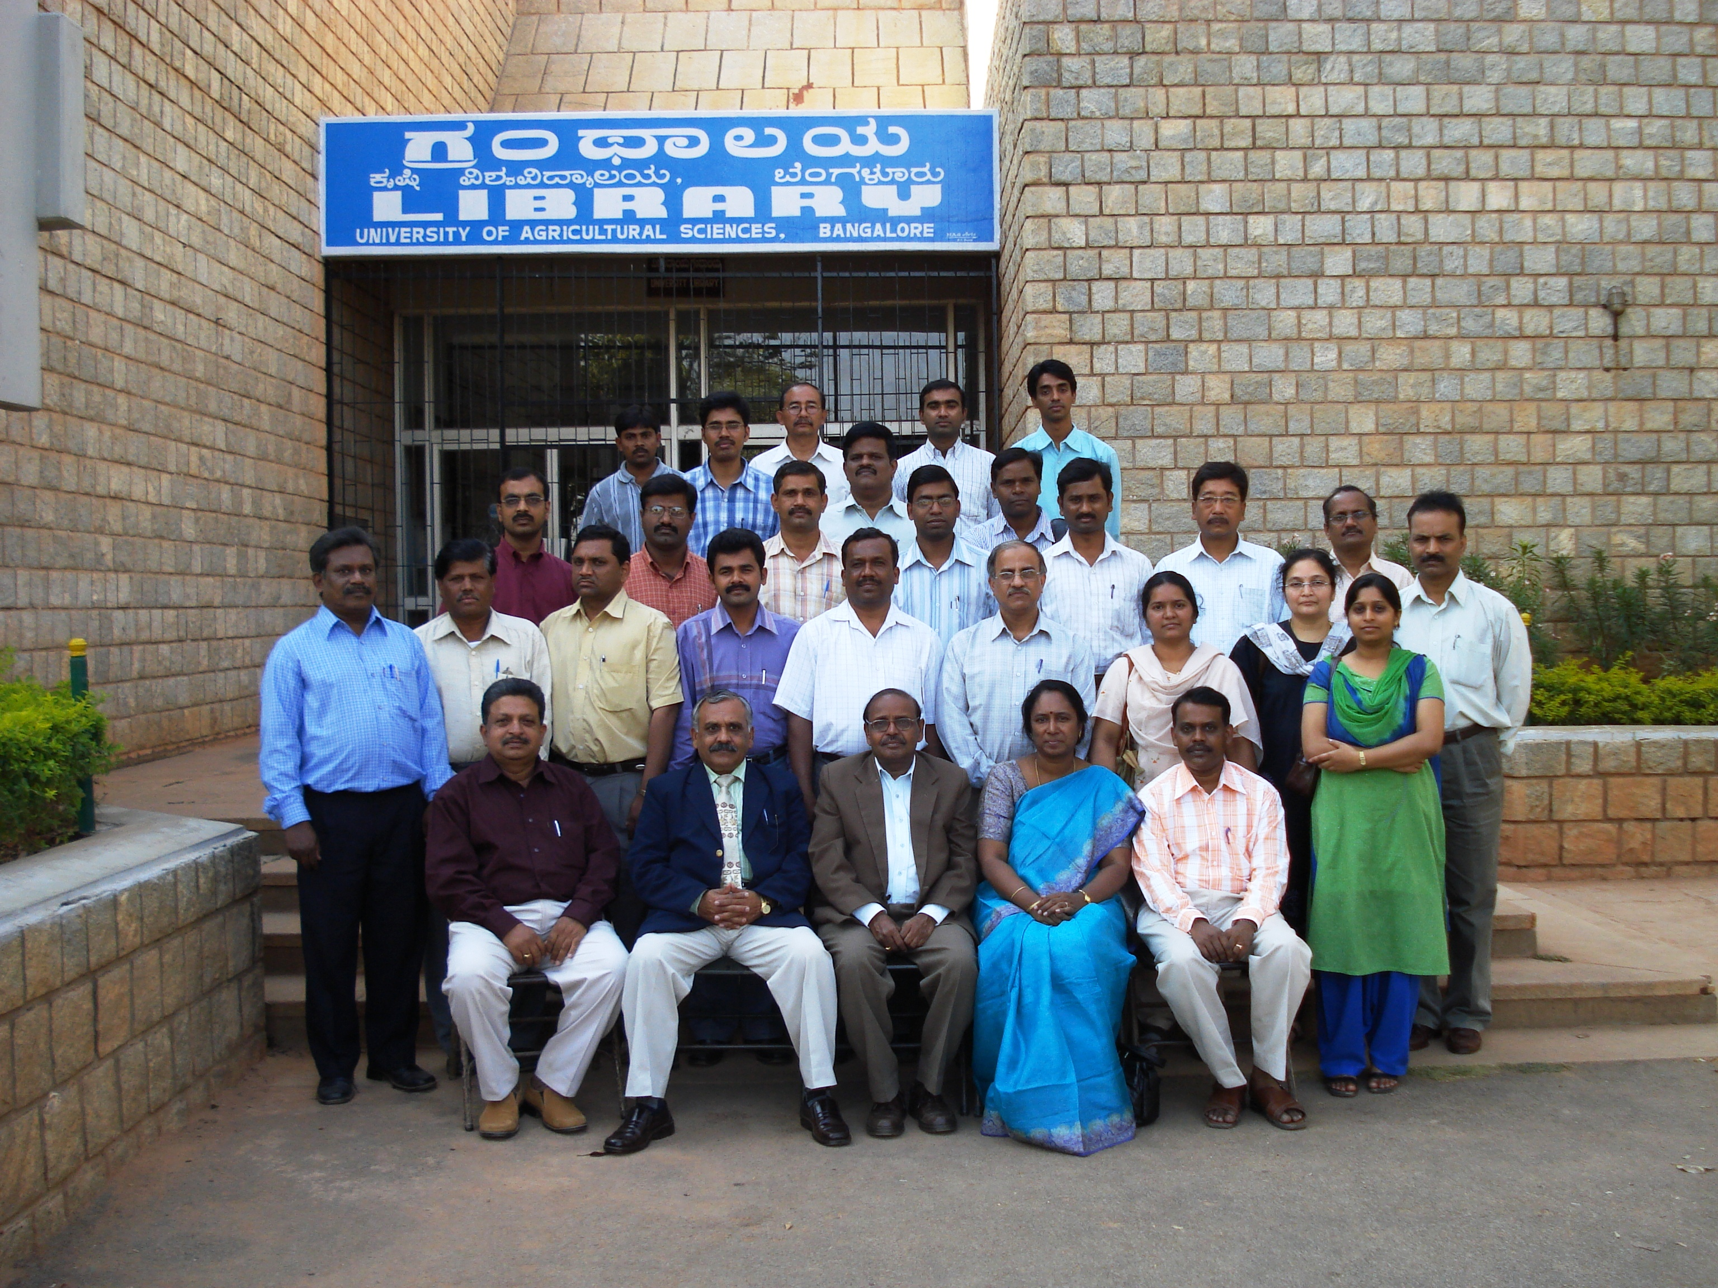
L-R: Dr.D.M.Gowda, Professor of Statistics and Head, ARIS Cell, Dr.P.G.Chengappa, Vice-Chancellor, Dr.T.K.Prabhakarasetty, Director of Research and Chairman of the ARIS Committee, Dr.Lakshmi Murthy, Scientist, MANAGE, Dr.Acharyulu, Scientist, MANAGE, Hyderabad and participants.

